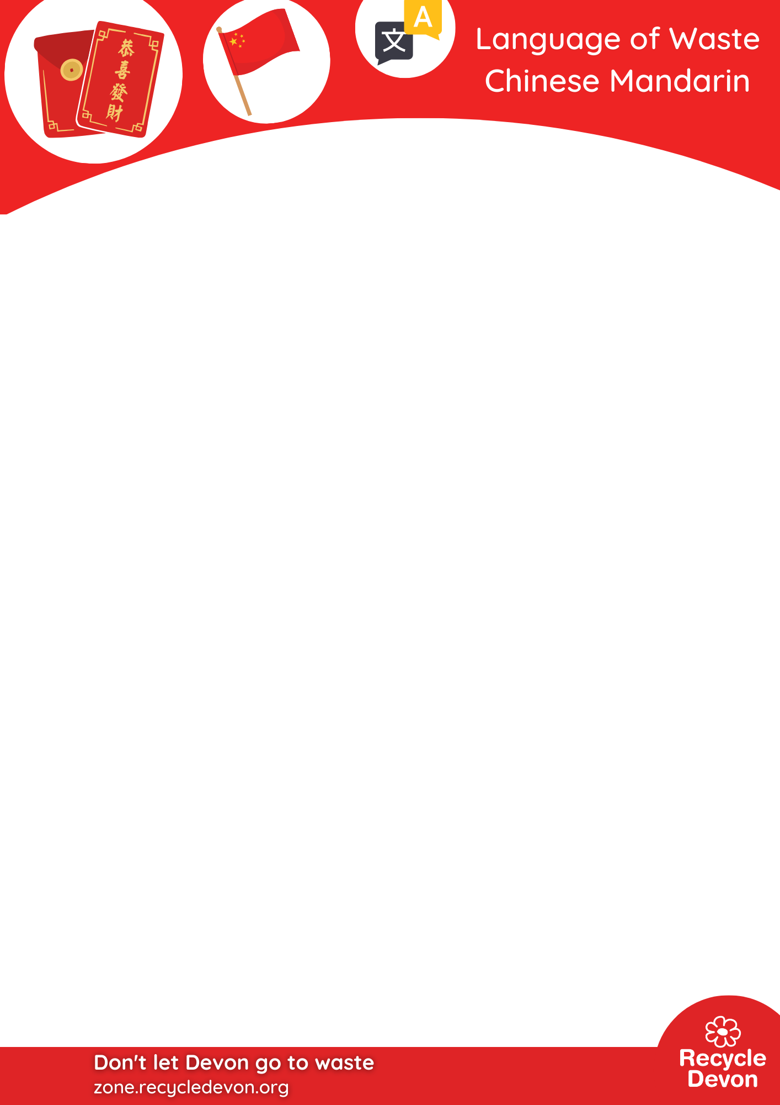
Match the Mandarin words to the English words
d

  Waste |   Recycling |   Bin
  Energy from Waste | 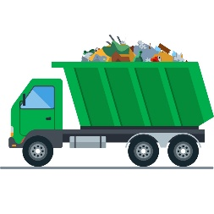  Bin lorry | 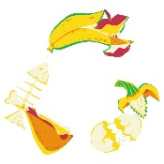  Food waste
  Landfill | 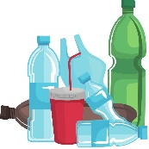  Plastic |   Batteries
  Litter |   Mending |   Sustainability

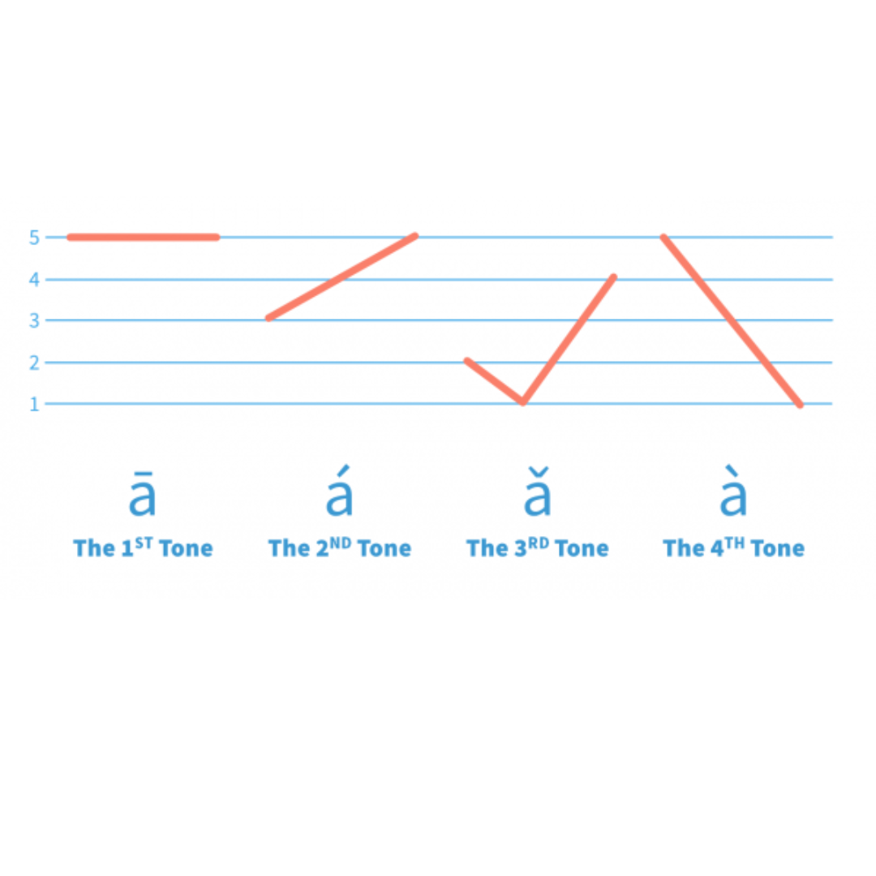
The second most spoken language in the world with 1.3 billion people speaking it. The markings in Chinese dialects change the pronunciation, like adjusting your pitch in music. Although Chinese may seem challenging, its grammar can be simple. There are no verb conjunctions, tenses, articles, or plurals. The image below serves as a guide on how to pronounce tones. The image below is from https://chinesefor.us/lessons/mandarin-pinyin-first-tone-pairs/
Translations
废品 (fèipǐn) - Waste
废品回收 (fèipǐn huíshōu) - Recycling
垃圾桶 (lèsè tǒng) - Bin
从废品中获取能源 (cóng fèipǐn zhōng huòqǔ néngyuán) - Energy from Waste
垃圾车 (lèsè chē) - Bin lorry
厨余垃圾 (chú yú lèsè) - Food waste
垃圾填埋 (lèsè tián mái) - Landfill
塑料 (sùliào) - Plastic
电池 (diànchí) - Batteries
垃圾 (lèsè) - Litter
修补 (xiūbǔ) - Mending
可持续发展 (kě chíxù fāzhǎn) - Sustainability



