

Cause and Effect Web Diagram: Systems Thinking

What is Systems Thinking?

A system is an organised collection of parts that when added together achieve a common goal, e.g. the human body whose overall aim is to stay alive and pass on their genes. We know it is a system because if you chop a human in half you don’t get two humans!
Systems thinking allows us to consider that all things are connected and can help us solve complex and “wicked” problems. We need to establish what are the symptoms and what are the causes of problems before coming up with solutions.

Use the Example web to help think about the causes and effects in complex systems.
There are too many cars on the road
Lots of cars
The Motorway is noisy: I can hear the motorway from my desk and it is loud.
Causes
Effects
Air pollution
Traffic noise
Climate change
Issue
It’s summer in Devon

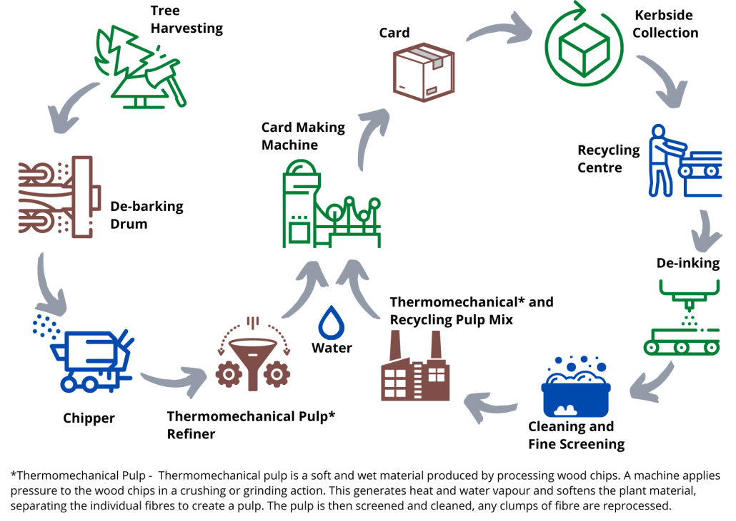
The Cardboard Making Process

