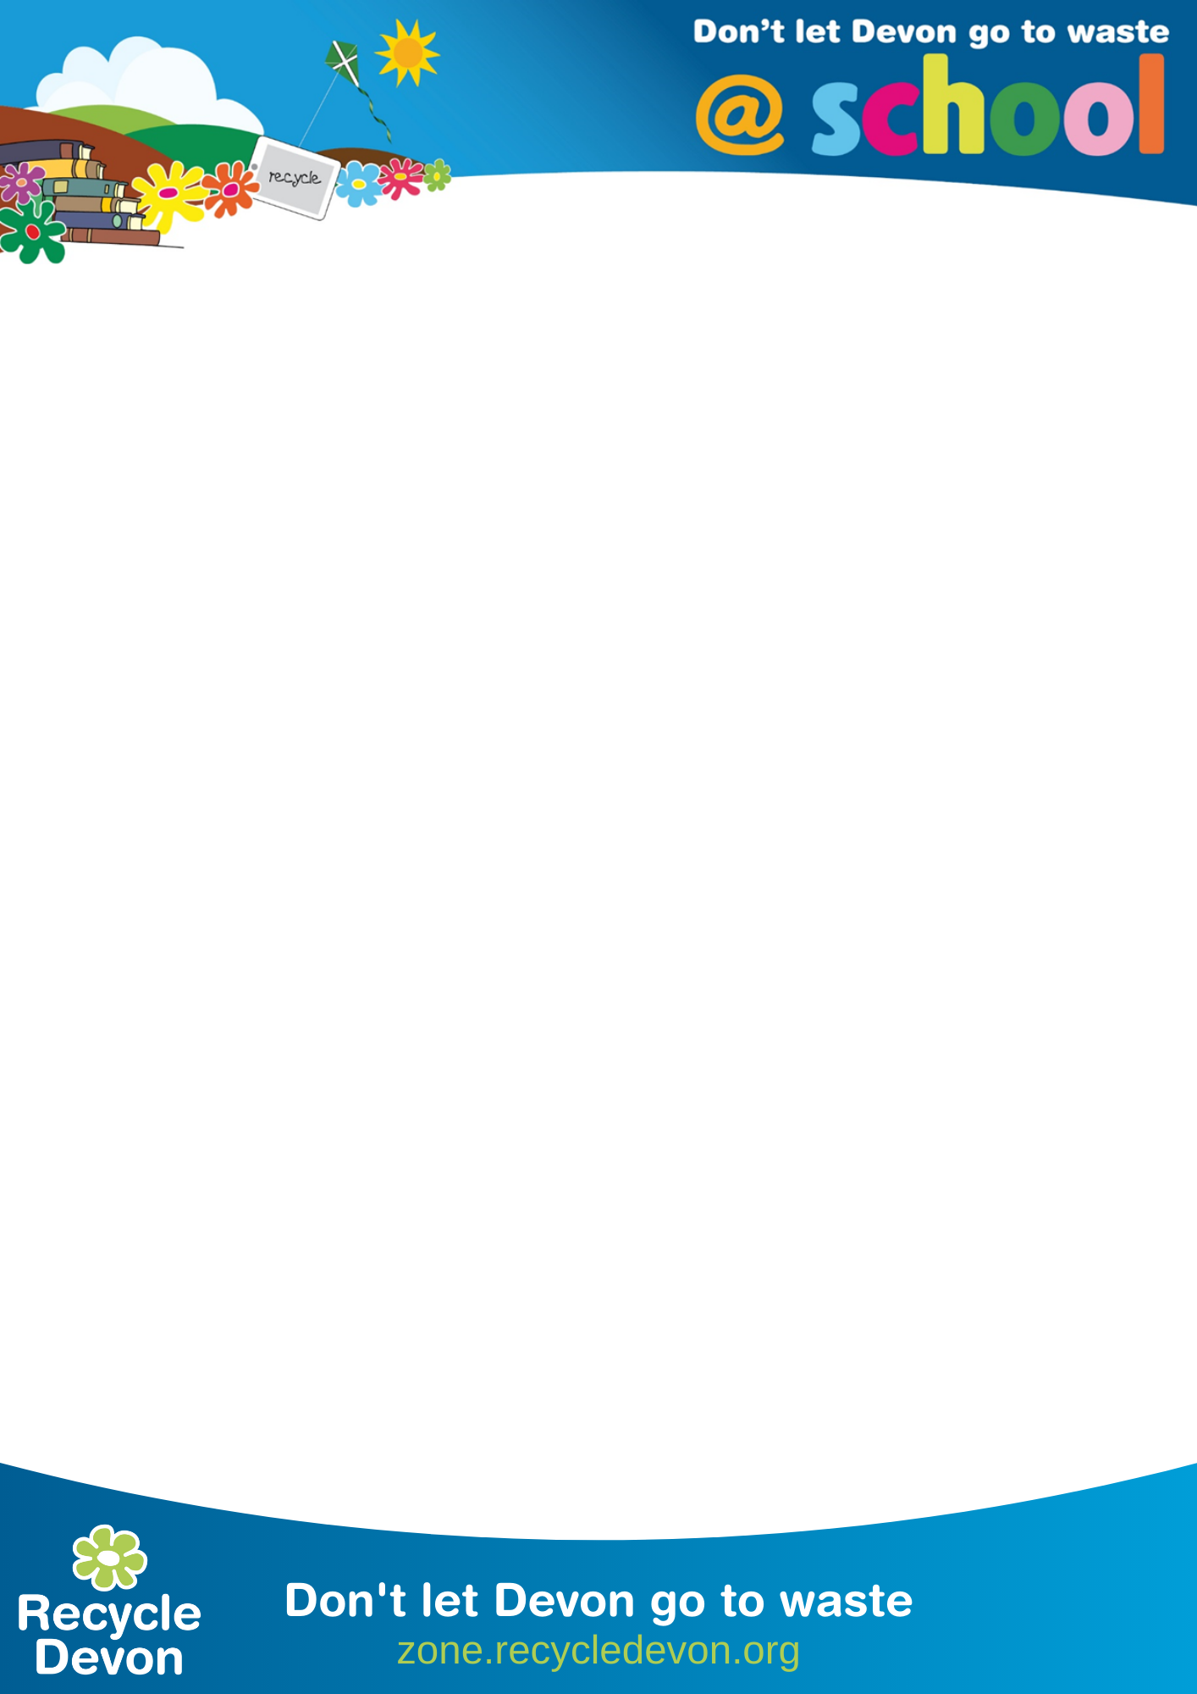

EfW Trip Assembly – Teachers Notes

NB: These notes accompany the Powerpoint files you can download from: https://zone.recycledevon.org/energy-from-waste-assembly and you and your class should have been on a Site Visit / Free School Trip to one of our Devon Energy from Waste (EfW) plants.

Slide 1: Introduction
Add in the class name and the date of the visit

Slide 2: A picture of the Exeter or Plymouth plant – check you have downloaded the right version for the trip you did.
Optional: You could insert a slide in here with your class photos if you took any.

Slide 3: What does an EfW do?
You could get a student to read out each one of these points, or add in any others that you like.
- They burn rubbish to make energy (electricity and heat)
- They are better than landfill sites as a way of getting rid of our rubbish
- They power homes and businesses
- They are on all year round, 24 hours a day, 7 days a week
- The bottom ash from the fire is recycled into aggregate for road-building
- The gases from the fire are scrubbed clean before they go out of the flue stack (chimney)

Slide 4: The EfW Process
The class could teach the process to the rest of the school –
Optional: you could also show the EfW video here. It’s on YouTube here: https://www.youtube.com/watch?v=cFpHaCd76Is

Slide 5: The three Rs Reduce – Reuse – Recycle
Can you remember the 3 Rs and some examples?

Slide 6: Things we enjoyed
Ask your class to add in some of the things they enjoyed or were memorable about the trip.

Slide 7: Things we didn’t like
Add in things that the class didn’t like

Slide 8: Things we learnt
What did they learn?

End slide

