

Repair Café Wordsearch
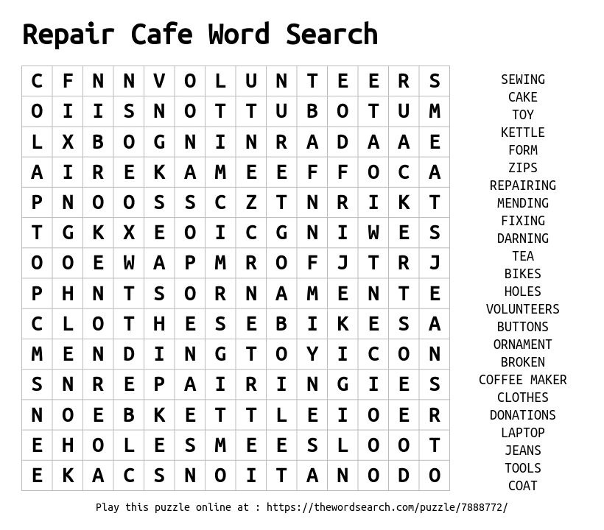
This wordsearch contains the words associated with repair cafes, plus the most commonly mended items. If you have a broken item why not find your local Repair Café and see if they can fix it.

Solution:
