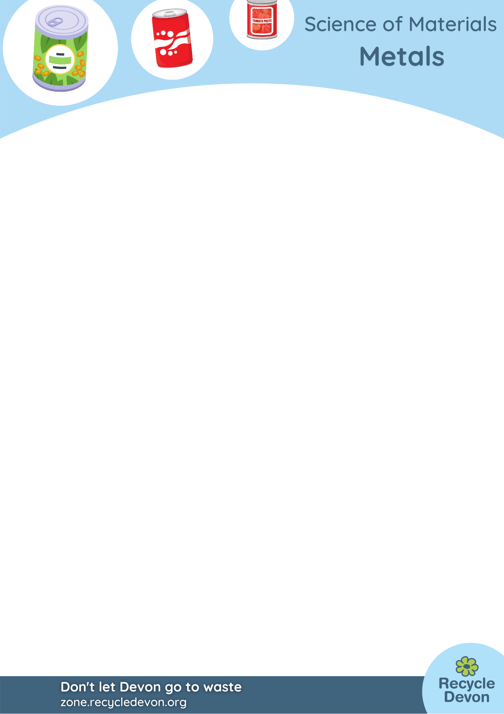


Metals KS2: Magnetic Barriers

Lesson Objective:
Children will learn which recycled materials are magnetic and experiment with barriers to magnetism.

Science National Curriculum links:
Y3 – Observe how magnets attract some materials; Compare and group together objects on the basis of whether they are attracted to a magnet and identify some magnetic materials.

Resources:

- Magnets
- Assorted clean household recycling including – sheet of paper, sheet of corrugated card, glass jar, plastic bottle/tub, aluminium can, steel can, sheet of plywood, piece of fabric
- Other assorted metal objects – nails, paper clips, etc
- Recording sheets


Time required: 2 hrs

Introduction to Activity:
- Talk about recycling at home, what we recycle, why (value of materials, saving resources, saving energy/carbon)
- Talk about commonly recycled materials.
- Ask children to discuss with a partner how you might separate out these materials if they were all mixed up.

Main Activity:
1. Test each of the materials with a magnet. Record which ones are attracted to the magnet and which are not.
2. Sort the materials into magnetic and non-magnetic materials.
3. Put the sheet of paper on the table. Place one of the magnetic objects on the paper. Put the magnet underneath and predict what will happen. Now see if you can move the can. Repeat with all the magnetic objects. Record the results.
4. Repeat with the sheet of corrugated card, piece of fabric, piece of plywood.
5. If time allows, stack the materials and see which combinations allow the magnet to pick up the metal items.

Results:
How many objects were attracted to the magnet?
Which objects were attracted to the magnet?
What materials acted as a barrier to magnetism?

Conclusion:
Discuss as a class what connects the objects that were attracted to a magnet.
Were they all made of a similar metal?
Were any objects a surprise? Perhaps children thought all metal objects would be picked up by a magnet.
Now discuss the barriers to magnetism – which layers of materials were a barrier to the magnet? Did different groups have different results? Were their predictions accurate?
Talk about how important it is to be able to sort mixed recycling materials into single streams so they can be recycled. Consider how you would best do this.
Ask children to consider what might happen if glass got into recycled paper (use sandpaper as an example). Or food waste was left in cans.

Plenary:
Use our KS2 Metals Quiz to test children’s knowledge after this lesson. See web page: https://zone.recycledevon.org/materials-worksheets/metals/

Explanation:
Magnetism is a strong, invisible force that acts on iron and steel. It is used to separate steel cans from aluminium cans in recycling plants. Magnetism was discovered more than 2000 years ago when people realised that certain rocks could attract pieces of iron. The story goes that a young shepherd was walking across a rock in central Greece when the nails in his shoes stuck to the ground. The place this happened supposedly gave magnetism its name – Magnesia still exists today and magnetite rock can still be found here.
Paper, plastic and thin card should let magnetism pass through them. Thicker card may act as a barrier, depending on the thickness of the card and the strength of the magnet.

Home Schooling & Extension Activity:
This could be run simply within the home using household materials and a fridge magnet. Ask children to record results and make predictions to encourage scientific thinking.
Ask the children to design a method to separate out the different materials. Ask them to draw a machine that separates out different materials.

Share your pictures with us on Facebook, Twitter or Instagram by tagging @RecycleDevon #recycledevon

Make sure you have permission and follow your school or organisation’s rules about sharing photos.

