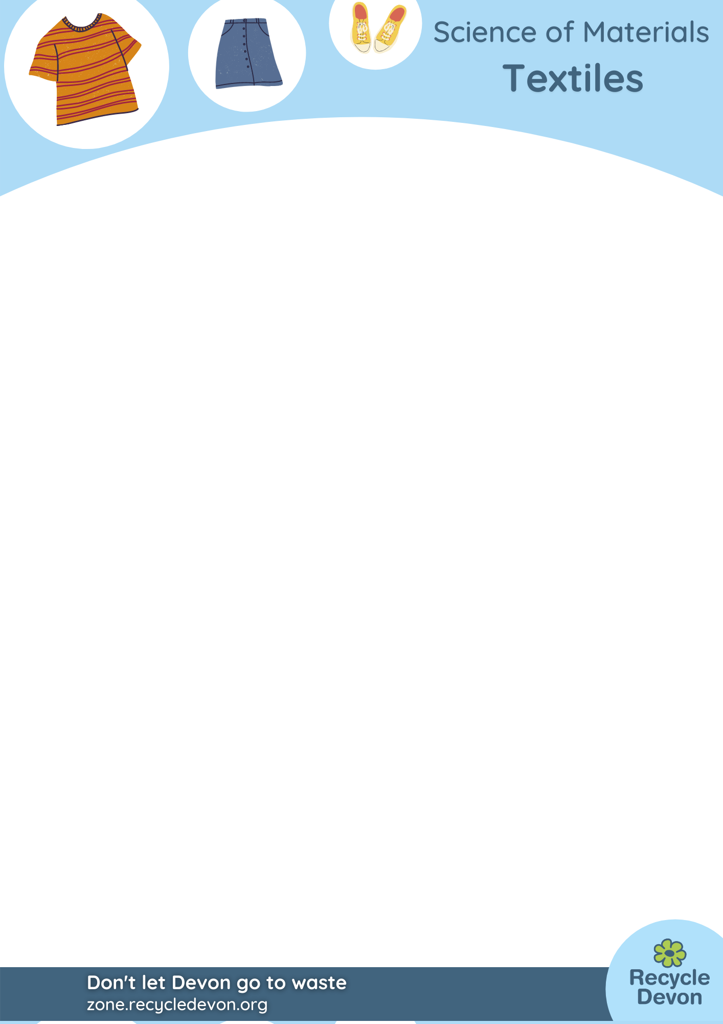
KS3/4 Activity: How Old Is That Jumper?!

Lesson Objective:

To understand how different types of textile decompose over time and relate this to biodegradability.

Science National Curriculum links:

KS3 Working scientifically – ask questions and develop a line of enquiry based on observations of the real world;

KS3 Biology – using microscopes;

KS3 Chemistry: Materials – properties of ceramics, polymers and composites;

KS4 Biology: Ecosystems – positive and negative human interactions with ecosystems;

KS4 Chemistry: Earth and atmospheric pollutants – microplastics;

KS4 Biology – the role of micro-organisms (decomposers) in the cycling of materials through an ecosystem.

Resources:

- Info sheets and timeline
- Samples of material (polyester, linen or cotton, viscose and wool)
- Examples of fibres (wool from sheep, cotton wool ball,
- Microscopes (optional)
- Dishes
- Tweezers
- Scissors
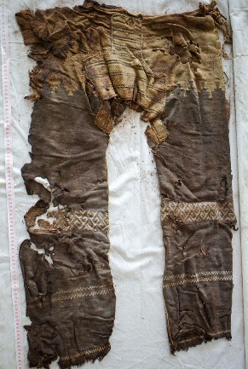
The oldest trousers in the world, dated at about 3000 years old, found in China. Photo from German Archaeological Institute (DAI)

Time required: 1hr

Introduction to Activity:


Textiles is the name given to clothes and other fabric items like bedding and towels. They are formed by spinning fibres into yarn and making them into fabric. They can be made from natural materials from either plants (linen, cotton, hemp) or animals (wool from goats, sheep or llamas) or woven from plastic polymers like polyester and nylon.


Different materials decompose at different rates. Plastic polymers will never decompose completely, but will break into small pieces called microfibres, which will persist in the environment indefinitely.

In this practical investigation pieces of material will be examined to determine how long they have been buried. This is used to inform a forensic science and history investigation.

Main Activity:
Introduce the activity with an explanation of textiles, which is a word students may not be familiar with. Ask them to look at their clothes labels to find out what fabrics they are wearing and what they think the material is made from. Many school uniforms are made with polyester blends. Talk as a class about why this is. Polyester was marketed as a “miracle fabric” as it could be worn for 58 days and still look pristine, without needing to be washed or ironed.
Explain that textiles are woven from fibres that have been spun together. You could show some videos here of wool being spun into yarn, or polyester fibres being produced (see our accompanying YouTube Playlist: https://bit.ly/32Sm3j0).

Framing this next part as a story may engage the pupils.
Explain that a sample of clothing (use polyester) has been found in school grounds and the pupils must work out how old it is. Talk about the use of forensic science to find out. How could the material be identified? Has a pupil left a jumper in the school grounds? Is it from a jumper left in the ground from before the school was built? Or is it from an Iron Age person…
Give the pupils samples of material to examine. Compare to labelled samples of fabric.

Optional – microscopes could be used at this point to look at the material and compare the fibres to samples. Students can use tweezers and scissors to separate the fibres out.

Ask students to look at the timeline to work out when the fabric could come from. Make sure they understand that plastic polymers for fabrics (nylon and polyester) were invented in 1941, so plastic from before this time cannot exist.

Explanation:
Talk about what would survive from the pupils clothing if left around in the environment. Plastic will last forever!
Talk about the role microorganisms have in decomposition of textiles in soil. The reason plastics don’t decompose is because there are no microorganisms around that can eat plastic yet.

Extension Activities:
How will future forensic scientists, archaeologists and historians use clothing to date remains?

Extra Resources:
Look at our materials pages to find out more about textiles and how they are recycled in Devon: https://zone.recycledevon.org/clothes/ and https://zone.recycledevon.org/external-resources/#clothing
Table of textile biodegradability and origin

Material | What’s it made from? | When invented? | Bio-degradable? | How long to decompose?
Polyester | Oil/ petroleum products | 1941 | No | Will break up into microplastics over about 100-400 years
Wool | Sheep or goat fleece | About 40,000 years ago | Yes | 1-5 years (depending on blend)
Linen | Flax fibres | About 5,000 years ago | Yes | 2 weeks in wet conditions;  2000 years in dry (see oldest trousers in the world)
Viscose | Cellulose from bamboo or birch | 1892 | Yes | 2 weeks to 2 months

More free online Resources:

https://www.fashionrevolution.org/
Find out about the industry behind your clothes and how we can all work to make it more sustainable.

https://edgexpo.com/2017/09/05/edge-fast-fact-non-biodegradable-clothes-take-20-to-200-years-to-biodegrade/
Find out how long your clothes take to degrade.

https://www.nationalgeographic.co.uk/history-and-civilisation/2017/11/worlds-oldest-dress
https://www.toptenz.net/10-oldest-pieces-clothing-accessories-world.php
https://phys.org/news/2009-09-archaeologists-oldest-known-fiber-materials-early.html
Read about some of the oldest textiles found.

