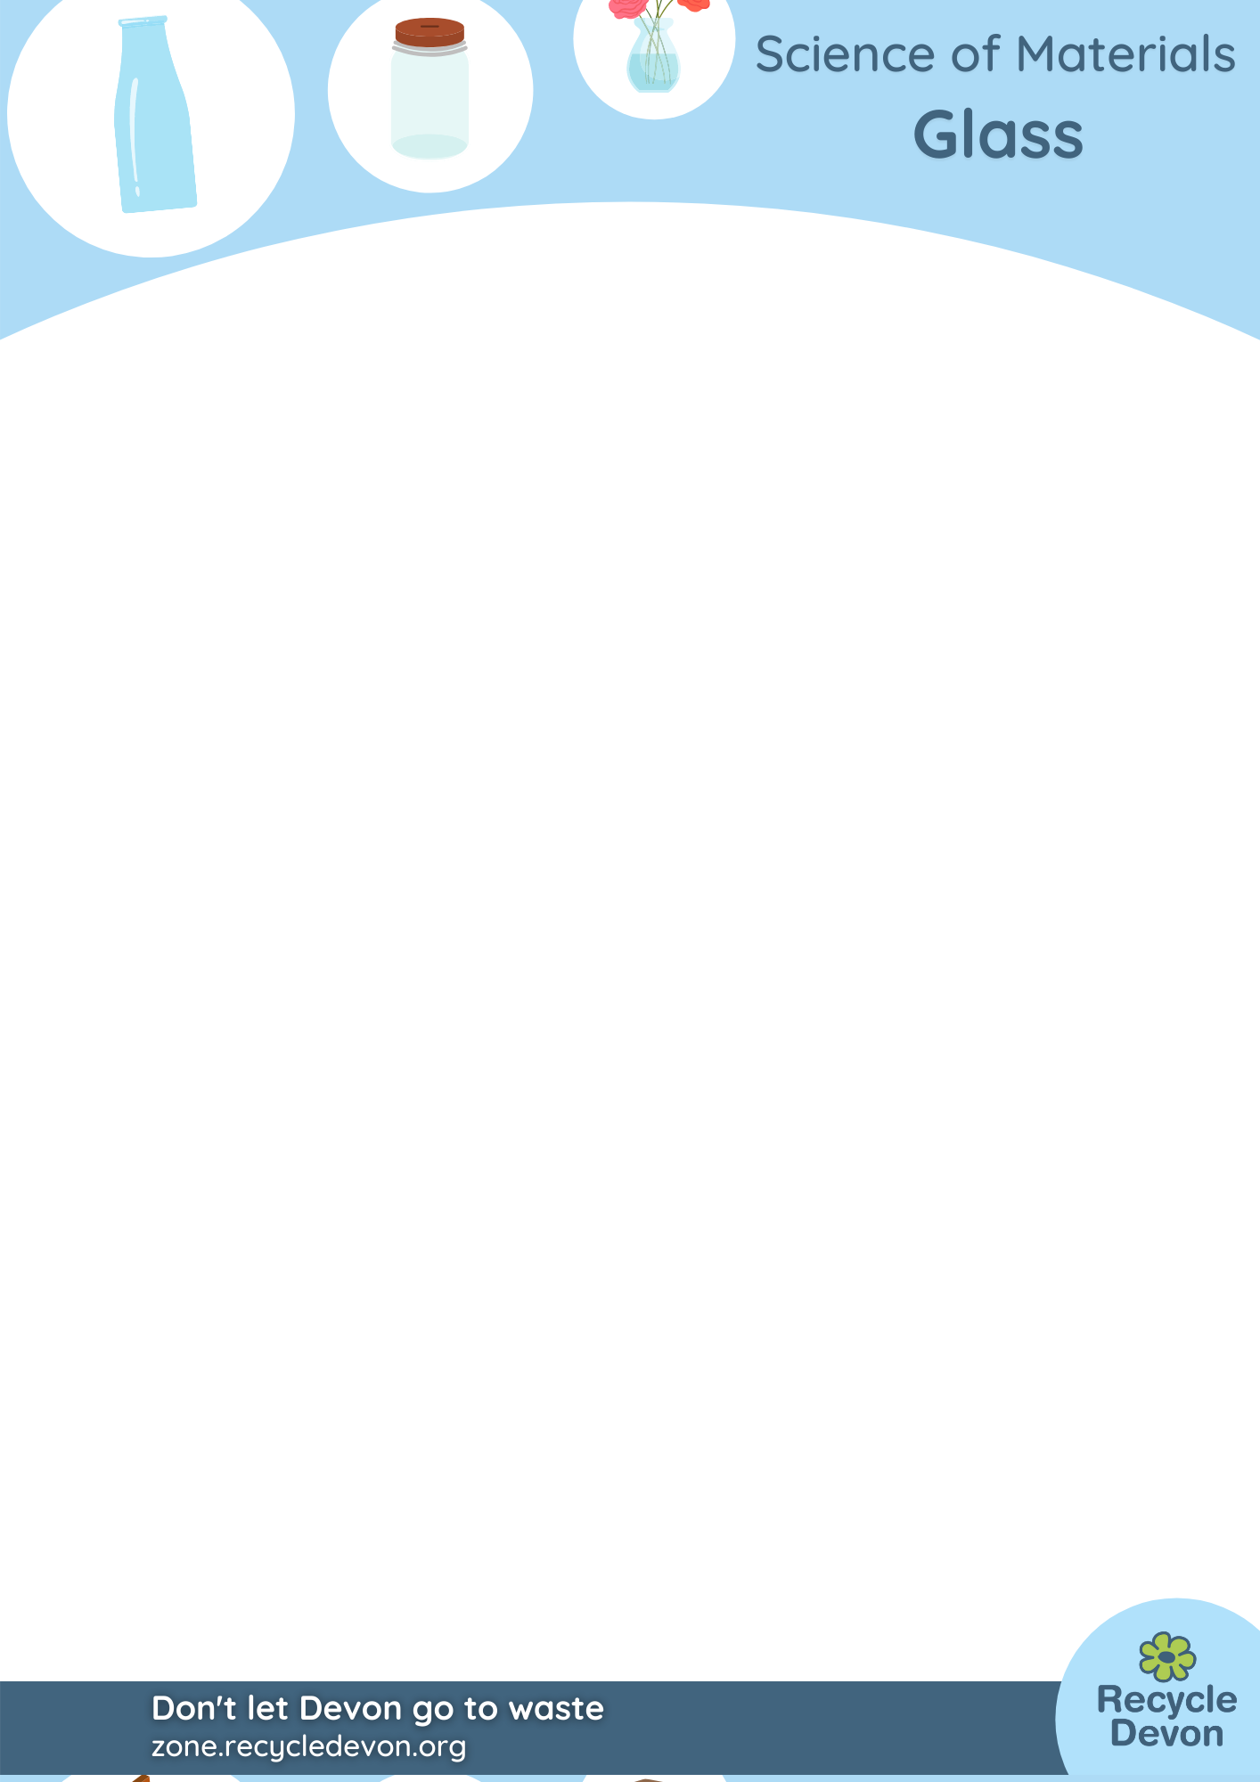

Glass KS3/4: The amazing disappearing glass

Lesson Objective:

To investigate refraction of light by making glass disappear.

Science National Curriculum links:

KS3 Physics: Light waves – pupils should be taught about the speed of light, transmission of light through materials, use of the ray model and the refraction of light.

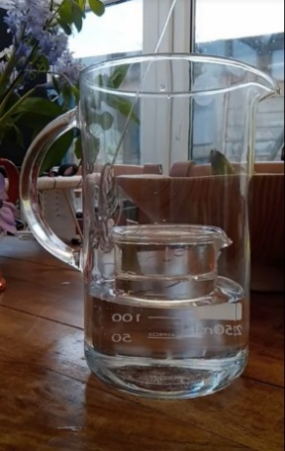
Resources:
- Baby oil or vegetable oil
- Water
- Large clear Pyrex glass bowl or Pyrex glass beaker
- Clear Pyrex glass cup or beaker small enough to fit into the larger one

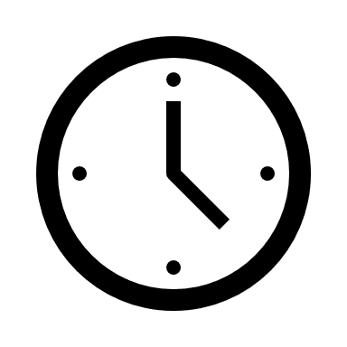
Watch a video of this activity on our Zone website.
Go to http://zone.recycledevon.org
Time required: 60 mins

Introduction to Activity:

Glass is usually transparent or translucent, but you can usually see it as the edges reflect light. This experiment makes glass disappear!

Students will notice how density of liquids affects the refraction of light.

Main Activity:

Fill the larger jug or bowl with baby oil until the oil has a depth of slightly less than the height of the cup.

Place the cup into the baby oil taking care not to allow oil to pour over into it.

Now slowly pour baby oil into the smaller cup or beaker. Observe the cup gradually disappearing as it fills with baby oil.

Try the experiment again with water. Is there a difference?

Results:

The disappearing glass when the oil is added to the second glass is because of refraction.


Figure 1: Waves being refracted as they pass from one medium to another
Waves approaching
Medium 1

Medium 2
Refracted Waves

Discussion:

Why does the glass disappear in oil and not in water?

Why does it happen so fast?
Waves are vibrations. A progressive or moving wave carries energy from one place to another without transferring any material. Light behaves as a wave in this way. We feel heat energy and see light energy from the sun or a light source. Waves can be reflected, refracted and diffracted.

Refraction is the change of direction a wave takes when it enters a different medium. The change of direction is a result of the wave slowing down or speeding up.

This experiment works because Pyrex glass has the same refractive index as baby oil.

Extension Activity:

Use mirrors to reflect light. Try making a light maze using Lego and mirrors. See https://www.science-sparks.com/science-fair-projects-light-maze/

Experiment with the speed of light. If you film the experiment could you slow the film down enough to work out how fast light travels?

What further applications could this knowledge of refraction be used for? Could you make other objects disappear or vanish into thin air using refraction?

Home Schooling:

This is an excellent introduction to a home school topic of light, refraction and reflection.

Extra Resources:

Pyrex glass has extra elements like boron and aluminium added to it to make it stronger and more resistant to heat, which makes it ideal for science experiments using heat or cooking. Pyrex has to be recycled separately from other glass. Check your local information, but Pyrex should be taken to Household Waste Recycling Centres if you live in Devon.

There are some great videos showing how this experiment working. Check out our other resources.

This BBC topic on BBC Bitesize is useful as revision for GCSE Physics.

Refraction - Light waves - KS3 Physics Revision - BBC Bitesize

