Food KS1: Making a Rot Pot

Lesson Objective:

Pupils create a miniature compost heap in a bottle using a range of materials and observe it over several weeks to learn about the process of bacterial decomposition.

Science National Curriculum links:
KS1: Working Scientifically
Y2 Science: Living things and their habitats – explore and compare the difference between things that are living, dead and things that have never been alive.

Resources:
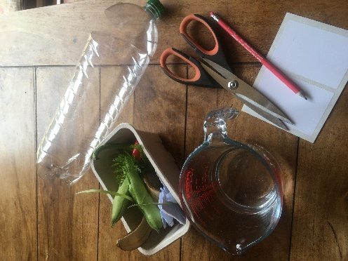
- Rot Pot recording sheet
- Clean 2L clear plastic bottles (1 per group)
- Masking tape
- Scissors
- Sticky labels and pencils
- A jug or watering can
- Compostable material such as fruit and vegetable scraps, garden waste, shredded paper, cardboard and wood shavings
- Antibacterial soap or hand sanitiser
- Gloves (optional)

Time required: 45 mins then 10-15 minutes each week to observe the rot pots as they decompose.

Introduction to Activity:
What do pupils know about compost? Do any children have a compost bin or heap at home in the garden? Does the school have a compost bin? What materials can we put in a compost bin? (Talk about stuff that has been alive and stuff that has never been alive to explain about biodegradable and non-biodegradable materials. Everything that has once been alive can be composted.)
What organisms are involved in the process of decay? What conditions do these organisms need? See Box

Main Activity:
- Remove the lid of the clear plastic bottle and cut around the top part, leaving a hinge.
- In pairs / small groups, pupils select a plastic bottle and add the compostable materials in layers.

- Once the bottle is full to the open rim, add a little water (about two tablespoons) to moisten the ingredients.
What do micro-organisms need?

- Micro-organisms (bacteria and fungi) need air, water, warmth and food.
- In a compost bin the water comes from fruit waste, vegetable peelings, and green leaves (the ‘greens’).
- Tough, woody materials such as cardboard, wood shavings, dead leaves and small twigs (the ‘browns’) provide air pockets.
- Both types of ingredients provide food for the micro-organisms.
- Warmth is provided by the sides of the compost bin and is created by the decomposition itself.
- Decay and decomposition are nature’s way of recycling living things.
- Fold over the hinged section and secure with masking tape.
- Choose a name for the rot pot, write it on a sticky label and stick it onto the bottle.
- Having washed their hands, pupils can make a careful record of what they have put into their rot pot using the rot pot recording sheet.

Results:
Pupils can make predictions about what will happen to the contents of their rot pots over the next few months. Results are recorded on the Recording Sheet.

Discussion:
Groups share what they put into their rot pot. Then groups discuss the best location for their rot pots, based on their knowledge of the conditions needed for decay. All rot pots can be placed together on a windowsill or outside, or a variety of locations.
Discuss what should happen to the plastic bottle after the experiment is over. It can be emptied, rinsed and put into the recycling.

Extension Activity:
Experiment with different locations for the rot pots by changing one variable e.g., temperature, amount of light. Experiment with different proportions of ‘greens’ and ‘browns’ and record the differences in decomposition.
Children could create a time-lapse video of a rot pot.
Why not take this activity further and use the knowledge the children have gained to create a compost bin outside in the school grounds or at home? Compost bins are a fantastic learning resource and will provide free compost for school gardening projects too. See our advice online: https://zone.recycledevon.org/composting/.

Home Schooling:
This activity would work well at home, either as a summer holiday project or as a home education activity.

Extra Resources:
This activity first appeared in the Compost Curriculum, which is full of activities for primary classes and Eco-Groups around compost. Great for teachers wanting to get outside the classroom and into school grounds! Download it for free on the Zone website: https://zone.recycledevon.org/composting/#compost-curriculum


Food KS1: Rot Pot Recording Sheet

Pupils’ names
Rot Pot name

Put the name on a label and stick it on your rot pot.
Record  Record the different layers you have put in your rot pot on the picture here | 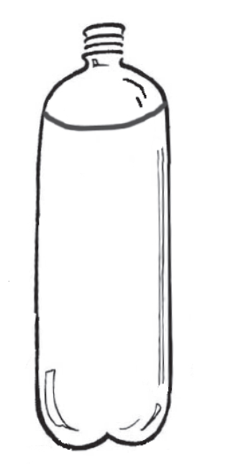
Predict

Predict what will happen inside the rot pot.

What changes might you observe?
Observe  Observe the pots regularly (every week or two).  Write down what you see. | Date | Observation

