Cardboard KS1 Activity: Boxing up teddy

Lesson Objective:

To make things out of cardboard boxes and discuss the properties of card that make it a suitable material for making some things, but not others.

Science National Curriculum links:

Y1 Science: Everyday Materials – describe the simple physical properties of a variety of everyday materials.

Y2 Science: Uses of everyday materials – find out how the shapes of solid objects made from some materials can be changed by squashing, bending, twisting and stretching.

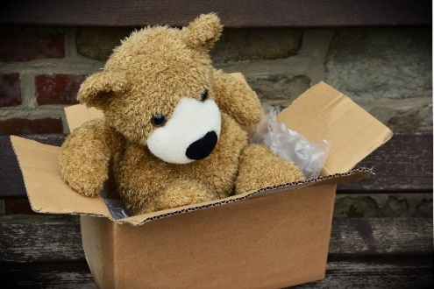
Resources:
- cardboard boxes
- extra sheets of corrugated card
- scissors
- teddy bear or other cuddly toys
- other packaging materials like tissue paper, packing nuts, brown paper, parcel tape.
- weighing scales
Cardboard box picture from Pixabay: free to use.

Time required: 1 hour

Introduction to Activity:
Cardboard is well known for being a great material for transporting items. This investigation will help children understand the properties that make it useful in this way.

Ask children if they have ever had deliveries arrive at their house in a box. Ask them why they think cardboard was used.

Ask them to think about the life cycle of a cardboard box. What is card made from? Is it made in a factory? Where does it travel? What happens in the home? Can it be reused? Can it be recycled?

Main Activity:
Divide the class into groups. Give each group a box, a cuddly toy and some other packaging materials. Try to make sure the box either too big or too small for the toy. Explain that they are going to send the toy to another child as a present. Encourage them to tell a story about who they are sending it too. Talk about the cost of postage will depend on how heavy the box is. Each group should pack and seal the toy so it is comfortably secure in the box. Weigh the box before and after packing.
DID YOU KNOW? *
Cardboard is made from cellulose from trees. The first cardboard box was made in 1817, though corrugated card was invented in China some time in the 15th Century. Corrugated card was first made at an industrial scale in 1874 by G. Smyth. The American Robert Gair invented the corrugated cardboard box in 1890.

Cardboard boxes usually have a high recycled fibre content. The Covid-19 pandemic saw a huge shift in public demand for cardboard boxes as more things were delivered to people stuck at home. This caused supply chain problems as more card was in people’s homes and council recycling collections struggled to keep up with the amount to pick up.

Results:
If the box is too big the group will need to pack the toy securely. If the box is too small then they will need to think of ways to increase the size of the box, perhaps by adding extra pieces of card to the walls of the box.

They could also think about swapping with another group to get a better sized box!
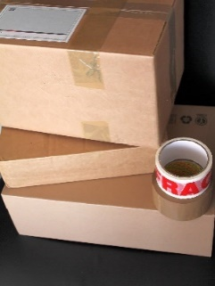
Discussion:
Talk about what makes cardboard good for transporting toys and other items around the world. It is durable, light, easy to recycle, and easy to carry. Talk about why it isn’t good for some things, like transporting stuff that is liquid, or transporting things in the rain. When it gets wet it gets soggy and heavier and the contents could be damaged.
Explain how important it is to reuse items before recycling them, as energy is needed to recycle items and it is better for the environment to reuse them. Pass sturdy boxes onto other people before recycling them. Ask the class to think of more ideas about reusing cardboard boxes.
Cardboard box picture from Pixabay: free to use.

Extension Activity:
Take the boxes apart to see what shape is used to make up the box. Link to Maths – Nets and 3D shapes.

Extra Resources:
For further information see our collection of YouTube videos to accompany this activity: https://bit.ly/3DCGodM

* Facts from https://commercialcutting.com/history-of-cardboard/ https://www.edinformatics.com/inventions_inventors/cardboard.htm https://en.wikipedia.org/wiki/Corrugated_fiberboard https://www.ehow.com/about_6514103_properties-cardboard.html https://www.packsize.com/blog/corrugated/how-was-cardboard-invented/
Share your pictures with us on Facebook, Twitter or Instagram by tagging @RecycleDevon #recycledevon

Make sure you have permission to share any photos first.

