
Shared Responsibility: Tragedy of the Commons

“What is common to the greatest number gets the least amount of care.” Aristotle

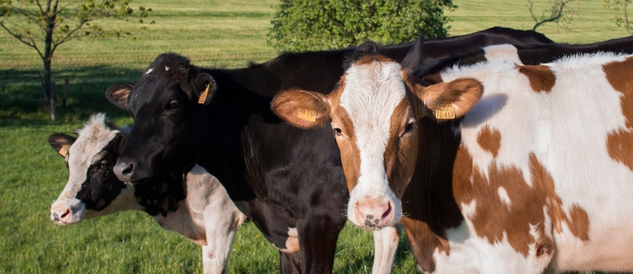
Imagine an open area of land, without fences, hedges or boundaries across it where cattle and sheep can graze freely. This common not owned by anyone, but everyone can use it to raise animals that feed themselves, their families and to sell at market. Imagine three farmers, Paula, Manuel and Victoria. They each have two cattle, who graze freely on the common ground. One day Manuel decides to buy another five cattle. He can now graze them for free, but there is less grass for the cattle of Paula and Victoria. The next week Victoria decides to invest in five cattle as well. Suddenly there is not enough grass for any of the cattle to graze freely.

The land can only support a certain number of animals; this number is called the Carrying Capacity. If there are too many animals the pasture will be overgrazed, as the grass won’t grow back quickly enough after it has been eaten. This means if all the farmers had too many animals than the land could support then no one would benefit as the pastureland would be overgrazed. All of the animals would suffer as they would not have enough grass to eat. This situation is called the Tragedy of the Commons.

This story can be used to describe other situations too. Examples of the Tragedy of the Commons include littering, pollution by fossil fuel burning, deforestation, overfishing, and many other environmental problems where scarce resources must be managed sustainably.

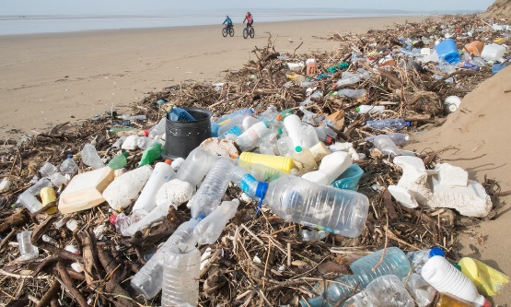
A classic example of the Tragedy of the Commons is in waste management. As a population grows it becomes more difficult to deal with the waste that is produced by human activity. Individuals keep their own homes clean and tidy, throwing waste away, but larger areas, like towns, are messier, as a few people litter or leave rubbish outside their homes. You may have noticed this in your own area.

When we think about the world as a whole waste is out of control, greenhouse gas emissions continue to rise, causing global warming and climate change. Toxic waste pollutes rivers and lakes, plastic pollution spreads across the oceans. Water and air are like the common grazing ground in the story, not owned by anyone, but affected by everyone. Everyone seems to think that pollution is not their problem, as they think they are doing enough in their own country, keeping their own rivers and countryside clean. However, the pollution from seven billion people is spreading across the oceans and into the air and will eventually cause us all harm. What should we do about these environmental challenges?

Solutions to the Tragedy of the Commons

Many of the environmental challenges that we face as a species do have easy answers. Once we are aware of the problems, we should be able to work towards solutions. The main way to deal with these problems is through education and then talking to each other, agreeing not to act in ways that hurt us in the future. Watch the TED talk by Erik Thulin (in our playlist here) about solving overfishing for a real-life example of solving a Tragedy of the Commons.

Working cooperatively, so that no one person, company or country takes advantage of the “commons” is a great way to solve the problem. Imagine again our farmers in the first example – if they talk to each other and agree not to have more than a certain number of animals, a total lower than the carrying capacity of the land then everyone will continue to gain from the common grazing land, and it won’t become degraded and unusable. This can be used for overfishing too. Another solution may be to keep a reserve of land back from grazing, or to rotate among other areas of grazing.

Can you think of some solutions to littering in the countryside or plastic pollution in the oceans?
- __________________________________________________________________________________________________________________________________________________________
- __________________________________________________________________________________________________________________________________________________________

Can you think of ways to make people or countries do this?
- __________________________________________________________________________________________________________________________________________________________
- __________________________________________________________________________________________________________________________________________________________

