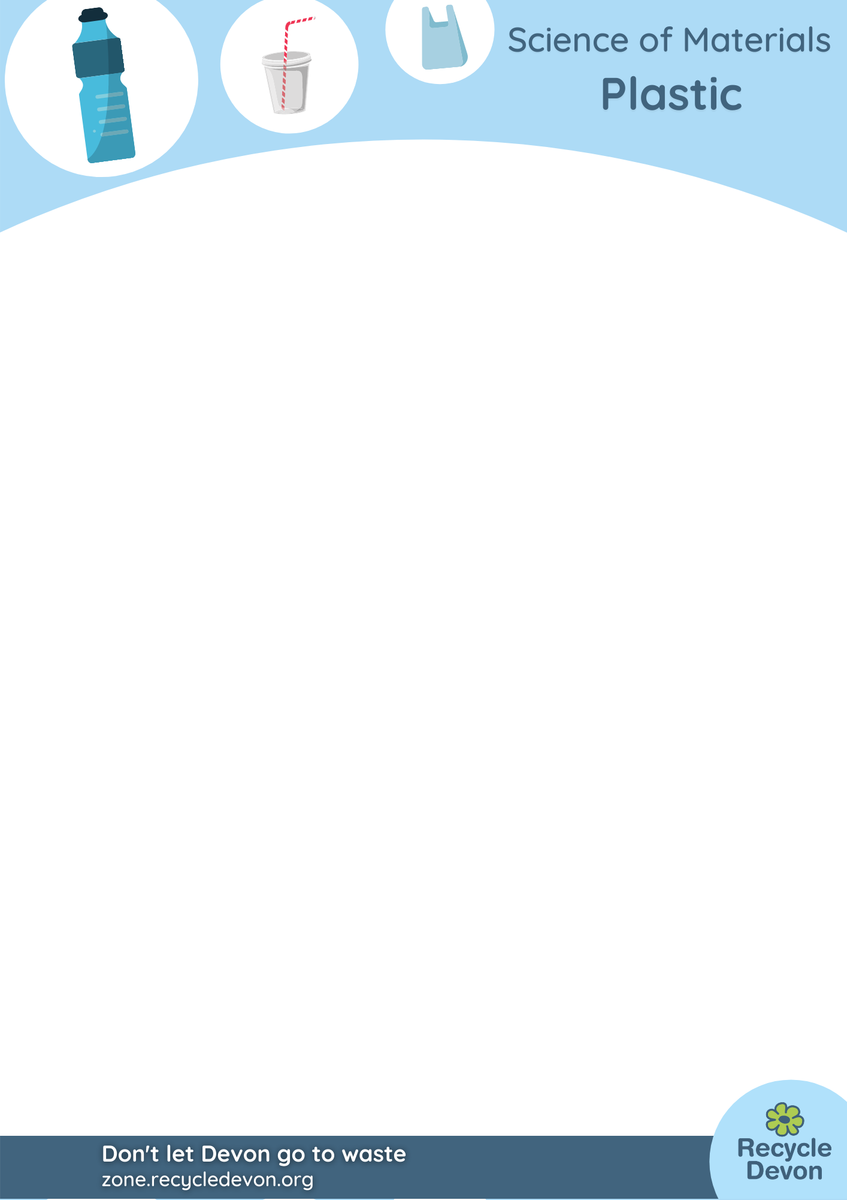
Home Education Activity: Comparing the Strength of Plastic Bags

Lesson Objective:
Students will perform a simple test to compare the strength of different types of plastic bags. Older students can find out what different types of plastic are used in plastic bags, including biodegradable plastics. Discussion follows about recycling film plastics.

Science National Curriculum links:
KS1 – Perform simple tests and observe closely;
Lower KS2 – set up simple practical enquiries, comparative and fair tests;
Upper KS2 – plan different scientific enquiries to answer questions.

Resources:

- A range of different plastic bags, eg. bread bag, thin bioplastic bag from a supermarket, thick reusable plastic bag, bag for life, salad bag.
- Several food tins (about 5-10)
- Weighing scales (optional)
- Space free from obstacles with no breakable objects

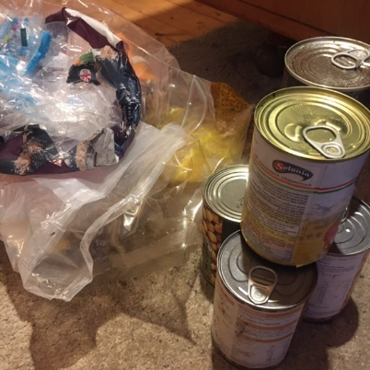

Time required: 45 minutes

Introduction to Activity:
Have you ever had a plastic bag break on you at the most inconvenient time? Did you drop all the contents on the floor? This investigation compares the tensile strength of plastic bags and can easily be done at home with minimal resources.

Main Activity:
Investigate how many cans a bag can hold before it tears. Hold the bag above a space free from obstacles and without any breakable objects nearby. Load a bag up with cans until it tears or breaks. Record results in a table. You might find that some bags are surprisingly strong. If you have a pair of scales weigh the cans to add up the mass that each bag holds.


Results:
Which plastic bag was strongest? What properties does plastic show? Explain why plastic is used so much as a material for food bags.

Explanation:
There are a range of plastics that plastic bags are made from. These are low-density polyethylene (LDPE), high-density polyethylene (HDPE) and polypropylene (PP). The main way to tell these three types of plastic apart are by sight and sound.

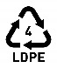 | LDPE feels soft and smooth. If you rub it together it will make a soft, swishing sound.
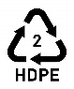 | HDPE feels harder and more crinkly. If the sound it makes when you rub it together is crinkly and sounds scratchier the plastic bag is probably made from HDPE.
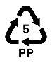 | PP is similar to HDPE, but importantly unlike HDPE and LDPE it does not stretch. It rips or tears.
 | Biodegradable bags are usually very smooth and soft, often with a biodegradable symbol on them.

In order to be recycled properly plastic must be sorted into the exact types. Sort your pile of bags into the different types of plastic listed above.
Have a look at this video to see a plant where plastic film is recycled: https://youtu.be/zRIRthGBvDA

Extension Activities:
You could repeat the experiment with other types of carrier bag, like paper or cotton – which would be stronger?

Try biodegradable bags compared to conventional plastic. If you have time you could leave bags outside in the sunshine for a few days or bury them in soil or in a compost heap so they biodegrade. Or put them underwater. How long before they lose their strength? Do they degrade differently in water, soil and sunlight?

Extra Resources:
Have a look at more of our resources about plastics and their recycling online at http://zone.recycledevon.org/plastic.

There are lots of brilliant resources about plastics and their properties and how they can be sorted available online. Try these worksheets for more ideas.
http://www.ciec.org.uk/pdfs/resources/plastics-playtime.pdf
https://practicalaction.org/schools/plastics-challenge/
Share your pictures with us on Facebook, Twitter or Instagram by tagging @RecycleDevon #recycledevon

Make sure you have permission to share any photos first.

