Recycle Devon Girlguiding Badge

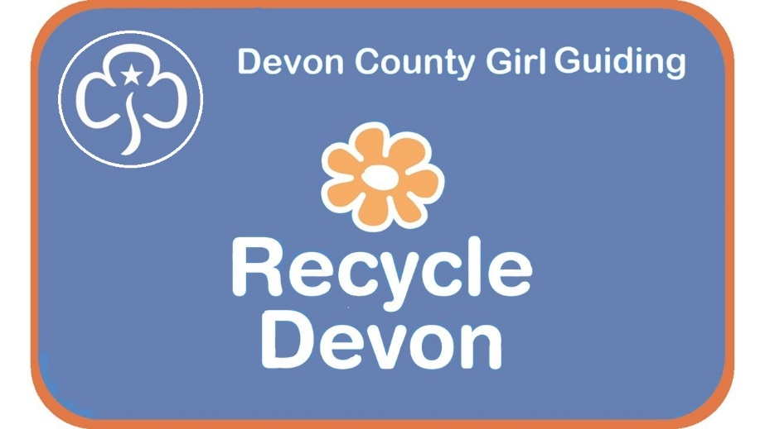
“Leave this world a little better than you found it.”
Lord Robert Baden-Powell – founder of the Scout and Guide movement
Leader Resources

By earning this badge your Guides, Rangers, Brownies and Rainbows will become more confident about what to recycle and how to reduce their waste.



Recycle Devon Girlguiding Badge
Learning to Reduce, Reuse and Recycle is fundamental to living well on our planet. Our seas are full of plastic waste and our countryside is littered with rubbish.

By helping Guides, Rangers, Brownies and Rainbows to use the 3Rs and by involving them in initiatives that clean up their local environment we hope that Devon Girlguiding, their leaders and parents can help look after Devon and the world for future generations.

This pack contains everything you need as a leader to help your Rainbows, Brownies Guides and Rangers earn their special Recycle Devon badge and record their progress. The activities can be done through a series of sessions or pick and choose those that will suit your programme. This guide also contains links to Activity and Skills badges.

Covid-19 Advice: Activities marked with a red star (∗) would be suitable for doing at home, with parental supervision.

“Let’s go for it leaders and use these great activities to help all our girls understand the needs of our precious Devon environment”
Jean Corbyn
Devon County Commissioner

Acknowledgements

Thanks to Rebecca Lang, a Guide Leader from Ottery St Mary, for some of the words, ideas and activities included in this Leaders Pack. She created a 3Rs Challenge badge for her group to help earn her Queen’s Award which she has been kind enough to share with Recycle Devon.

The 3Rs – Reduce, Reuse, Recycle

The Waste Hierarchy
Best option for the environment
Worst option for the environment

Reduce
Reducing our impact on the world around us is all about reducing our consumption of the world’s resources. The more we buy the greater our impact on the environment. Reducing energy reduces carbon emissions, helping combat climate change, as well as creating less waste. Avoiding and reducing waste comes top of the list in the Waste Hierarchy. It means using less, buying less and so having less waste. There are lots of ways to do this – perhaps by buying items with less packaging or not buying things like bottled water but drinking water from the tap instead.

Reuse
Reusing something means using it over and over again, without changing it. For example, you could reuse a water bottle and refill it with squash or water rather than buying bottled water, or reuse bags for shopping instead of buying them in the shop.

Recycle
Recycling saves waste and energy, helps reduce climate change and reduces the amount of our waste that is burnt for energy or sent to landfill. However, recycling something also uses more energy than reusing it as the materials is often chipped up into small pieces and melted down to be turned into a new product. Whenever we buy something we should be buying a version made from recycled materials if it is available.

Rainbows
Rainbows should complete 6 of the 12 challenges below, with at least one from each section.

General
- Learn the 3 Rs actions and teach them to someone else. *
- Draw a poster about the 3 Rs. *
- Take part in a Litter Pick or Beach Clean.

Reduce
- Explain to a Leader what Reduce means and talk about a way you could do this.
- Show a Leader something you use or do that has reduced your waste (e.g. Having a reusable water bottle or learning to use paper on both sides before throwing it away).
- Encourage your family to make a choice that reduces your waste. *

Reuse
- Explain to a Leader what Reuse means and talk about a way you could do this.
- Make something useful out of junk (e.g. bird feeder from a plastic bottle – see instructions in the Resources section). Or make something from scrap material, like a reusable handkerchief (see instructions in the Resources section). *
- Find out where your nearest Reuse drop-off point is. This might be at your local Recycling Centre or it could be a secondhand shop. Or find out about your local Repair Café. *

Recycle
- Explain to a Leader what Recycle means and talk about a way you could do this.
- Help your parents to recycle at home for one week. *
- Show that you know what can and can’t be recycled in your local area. Maybe make a short video about the different items and which bin, bag or box they go in. *

Brownies
Brownies should complete 12 of the 24 challenges below, with at least one from each section.
General
- Learn the 3 Rs actions and teach them to someone else. *
- Record a video showing someone how to do the 3 Rs actions (watch our short video here: https://youtu.be/XOdUMuSZFug). *
- Draw a poster or write an information leaflet about the 3 Rs. *
- Take part in a Litter Pick or Beach Clean with your Brownie Pack, school or another community group.
- Find out about Energy from Waste plants in Devon. *
- Hold a meeting using only what is in the cupboards. Do not buy anything new. Can you do it?
- Create a meal or recipe using as little packaging as possible. Which fruit and vegetables can be bought without a bag? Are there ways of buying food without packaging? See the list of Refill shops in Devon here: https://www.recycledevon.org/zero-waste-shop-directory. *
- Complete a mini Waste Audit by looking at and recording the waste you create as a Brownie Pack. Make a plan to reduce, reuse and recycle your Pack’s waste. Use our handy mini Brownie Pack Audit Sheet and Action Plan found in the Resources Section.

Reduce
- Explain to a Leader what Reduce means and talk about a few ways you could do this.
- Record how much waste you produce in a week and think of ways you could reduce it. (Use our table for recording or auditing your own waste). *
- Show a Leader something you use or do that has reduced your waste (e.g. Having a reusable water bottle or learning to use paper on both sides before putting it in the recycling bin).
- Persuade someone else to reduce their waste. This could be by showing them how to reduce their food waste, or by suggesting alternatives to single use plastic like a reusable coffee cup. *

Reuse
- Explain to a Leader what Reuse means and talk about some ways you could do this.
- Make something useful out of junk (e.g. bird feeder from a plastic bottle – see instructions below). Or make handkerchiefs or napkins out of old cloth. (See extra resources). *
- Use old clothes in a creative way – why not turn old socks into puppets and perform a sketch or turn old tops into a new scarf or a shopping bag. (below are some examples but there are lots more examples online) *
- Have a bric-a-brac sale of old clothing, toys, crockery as a fundraiser.
- Find out where your nearest Reuse drop-off point is. This could be at your local Recycling Centre or it could be a secondhand or charity shop. *
- Find out where your nearest repair shop is*; this could be a seamstress who does repairs, an electrical shop that does repairs or a local Repair Café. If there isn’t one nearby - talk to your local community (perhaps your Town or Parish Council, local green or sustainability group or local church) about starting one.

Recycle
- Explain to a Leader what Recycle means and talk about some ways you could do this.
- Find out the current figures for how much of what we throw away is recycled or composted in Devon. * Our website might help you: http://zone.recycledevon.org
- Help your parents to recycle at home for one month. Find out when the recycling is collected and help sort and put it out. *
- Show your Leaders that you know what can and can’t be recycled in your local area – check your local District facilities here: https://www.recycledevon.org/recycling-collections
- Set up a wormery or compost heap. This could be at home* or with your Brownie group. See a useful video here: https://youtu.be/7Mqb5vicCOc
- Find out where your nearest Household Waste Recycling Centre is* and visit it with an adult to drop off some recycling or go to the Reuse shop. See our website: https://www.devon.gov.uk/wasteandrecycling/centre/

how much does devon recycle?
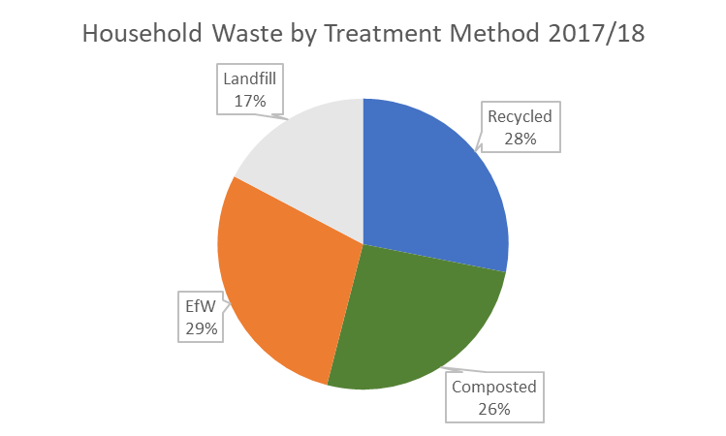

These figures are from 2017-2018. Food waste is composted in a recycling process called anaerobic digestion. Devon is one of the best counties in the country, with a recycling rate of 56%.

Guides & Rangers
Guides should complete 20 of the 40 challenges below, with at least four from each section. Rangers should complete 25 out of the 40 challenges.

General
- Learn the 3 R Actions, teach someone else how to do them and write instructions or record a video about how to do them. *
• Talk to someone who works in the waste industry, this could be someone at an Energy from Waste plant or Recycling Centre, or someone from the waste team at your local District Council or at Devon County Council, or another waste related occupation like a street sweeper or waste collector. Think of some questions to ask them and record your answers in some way. Share them with your group.
• Do a Litter Pick or Beach Clean with your group or participate in a school or community activity. You can do this with your family if social restrictions apply.
- Take part in a Community or School Action Day to raise awareness of plastic in the environment. Talk to our Education team about organizing one for your school.
- Find an area in your local environment that needs clearing up and do a litter pick. Record before and after photos and share them with the Recycle Devon team on Facebook or Twitter (tag in @recycledevon).
- Find out about Energy from Waste plants in Devon. See if you can arrange a trip for your school. *
- Write a letter to your local MP or District or County Councillor asking them to take action on waste in Devon. See the Resources section for a template. *

Reduce
  - Think of ways to reduce your waste or plastic use and record them on a poster or leaflet to show to your Leader. *
  - Write a record of plastic you use and throw away – use our useful table below*
  - Do something to reduce your waste – you could get your family to swap to milk delivered in glass bottles or start refusing plastic straws in drinks when you are out and about. *
  - Find out if your community or school is part of the Plastic Free movement. If not, then why not start a Plastic Free campaign in your community or school. See SAS resources online: https://www.sas.org.uk/plastic-free-communities/. *
  - Find out about the Refill campaign: https://www.recycledevon.org/RefillDevon. Ask your school to be a Refill School and find a building, business or shop that would like to be a Refill Station. Help them to register on the Refill app.
  - Organise a surplus food event or find out about Community Fridges and Larders in Devon. * See the Hubbub website for a guide: https://www.hubbub.org.uk/the-community-fridge.

Reuse
• Find out about where you can drop off items for Reuse in your area – check out your local Household Waste Recycling Facility, secondhand shops or a Reuse shop.
- Find out about Repair Cafés and repair businesses in your area. Go to one and take along an item to be mended.
- Find out about people who repair things (it could be sewing, bikes or computers) in your local area. You could invite someone to talk about what they do. *
- Learn how to mend something – this could be anything – from darning a hole in a jumper or sock to fixing a broken screen on a mobile phone. *
A Repair Café is run by volunteers -and helps people by repairing and mending items that would otherwise get thrown away. There are 10 active Repair Cafés across Devon
Picture copyright Mark Burley Photography

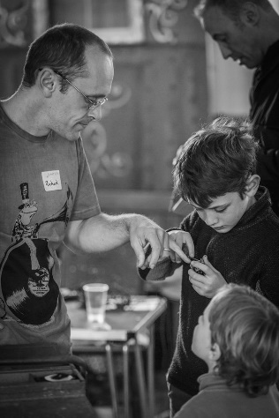

- Upcycle something. See our guide here: https://www.recycledevon.org/reuse/upcycling *
- Make something useful from junk. You could make a bird feeder from a plastic milk bottle or turn a yogurt pot into a plant pot. Make sure that the item can be recycled afterwards, i.e. don’t cover it in non-recyclable glue and paint and avoid glitter. See our instructions in the Resources Section. *
- Make handkerchiefs or napkins out of old cloth. (See resource section). *
- Organise and carry out a cloth collection drive. Find out if there are any local schemes that will give your Guide Unit some money for your old clothes. If you gain funds from the clothing, put it towards making your unit more eco-friendly or pass on the funding to a charity of your choice.
- Turn old socks into puppets and perform a sketch. *
- Turn old tops into something new like a scarf or a shopping bag. There are loads of ideas online. *
- Use old Christmas cards and turn these into new gift tags. Why not try using other leftover cards to create new Birthday or Mother’s Day cards? *
- Have a bric-a-brac sale of old clothing, toys, crockery or organize a jumble trail around your town/village as a fundraiser.
- Make clothes out of old newspaper/material and have a catwalk fashion show.
- Plan a meal made from leftovers. Cook it for your family or while on camp. See Recycle Devon’s useful advice and book on Food Waste here: https://www.recycledevon.org/recipebook *

Recycling
• Know what you can recycle at home and when it is collected – check your local District facilities and see our factsheets here: https://www.recycledevon.org/recycling-collections *
• Find out the current figures for how much waste in Devon is recycled or composted. Our website might help you: http://zone.recycledevon.org *
• Help sort recycling in your home for three months. *
• Investigate how your Guide Unit recycles materials where you meet.
• Find out where your recycling goes and what different recycled items can become.*
  - Find out where and how food waste is recycled in Devon. Present the information to your Unit in an interesting and informative way. This could be through a video or sketch, or a poster. *
  - Set up a recycling scheme at home, school or at your Guide hut. See Terracycle for difficult to recycle items. You can raise money for your group in this way.
  - Set up a wormery or compost heap at home* or with your Guide group. See some useful videos about these here: https://youtu.be/gA_g5aT56Fw and https://youtu.be/7Mqb5vicCOc. Record what lives in it and how it progresses.
  - Make some new paper from old paper (see Papermaking resources). *
  - Sign the online pledge for your local area- search the internet to see if your local area has an online pledge as a unit you can sign. If not, make your own for your unit and get everyone to sign it. Hang it up in the meeting place to remind people.
In Devon see: https://www.recycledevon.org/pledges *
  - Find out where you can recycle used ink/toner cartridges in your local area. See how many you can collect and recycle them. *

WHAT HAPPENS TO YOUR FOOD WASTE IN DEVON?

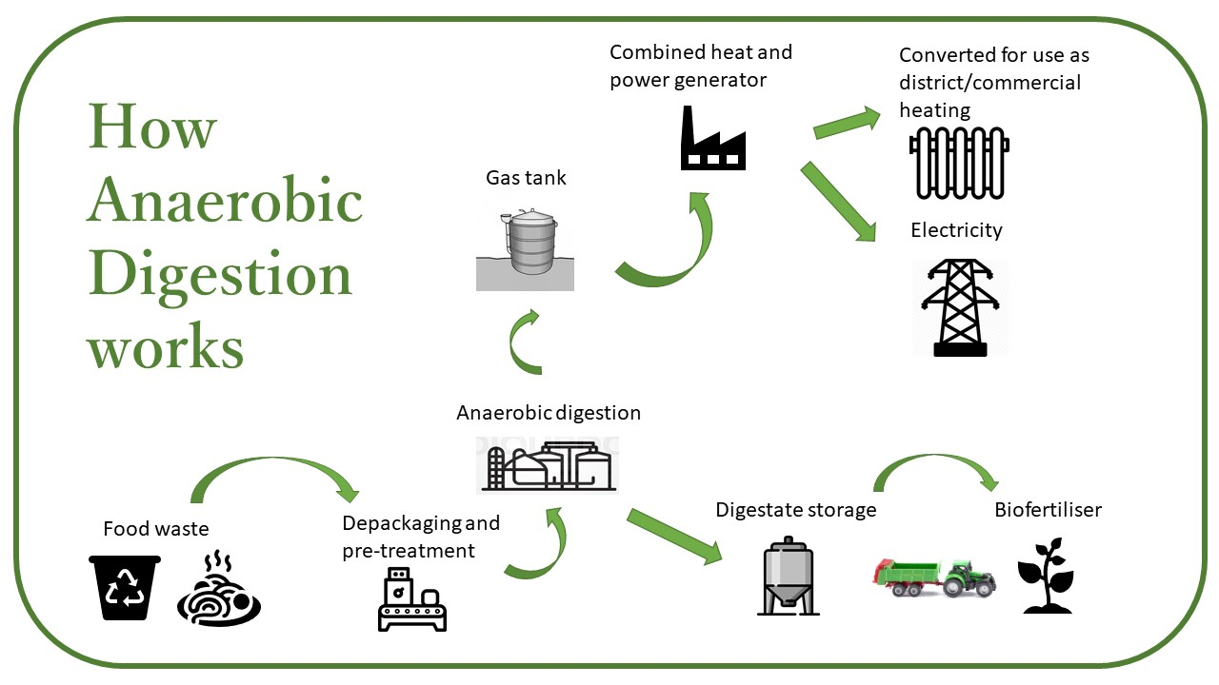
Also see our Food Waste video here: https://zone.recycledevon.org/food-waste/
Food produces a dangerous greenhouse gas called methane when it decomposes. By recycling food waste using anaerobic digestion, methane can be collected and burnt to make electricity. Most District councils in Devon now collect food waste to recycle it in this way.

RESOURCES
- Instructions for a plastic bottle bird feeder
- Instructions for making handmade handkerchiefs from old clothing
- Brownie or Guide Audit Sheet and Action Plan
- Table for recording plastic use
- Instructions for Papermaking
- Template letter for Councillors and MPs
- Index of Badge Links

Instructions for Junk Modelling: How to make a Bird Feeder from an old water bottle
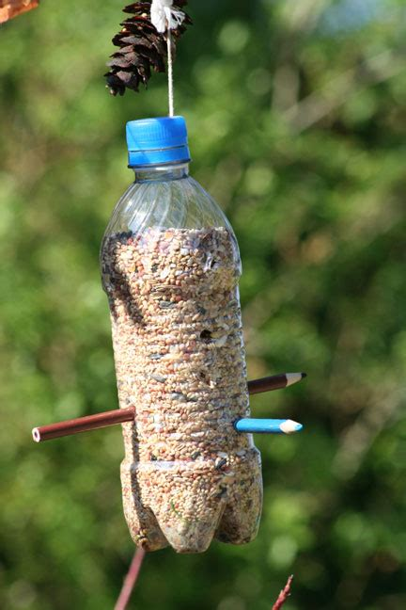
Materials: Water bottle with cap
Scissors
String
2 pencils or 2 dowels/thin pieces of wood
Bird seed

Method:
- Using a dry and clean plastic water bottle attach the lid and make a hole halfway up the bottle. Make another hole halfway up the bottle on the opposite side. Now poke the pencil or dowel through the water bottle.
- Make another pair of holes near the bottom of the bottle, at right angles to the first set. Poke the other pencil or dowel through. You have made 2 perches for the bird feeder.
- Carefully make a hole in the cap of the bottle and thread through the string to form a loop. Make a secure knot to attach the loop.
- Fill the feeder with bird food. Carefully cut out holes to allow some of the food to be accessible to the birds just above each perch hole.
- The feeder is now ready to hang up. Place in a position away from cats and other predators and watch and wait for the birds to arrive.
- Your choice of food will determine what kinds of birds you see arrive at the feeder. Sparrows and tits like large seeds like sunflowers. Finches like smaller seeds like niger seeds. Robins and blackbirds like a few mealworms. Larger birds like woodpeckers and jays will like big seeds and nuts like peanuts and maize.
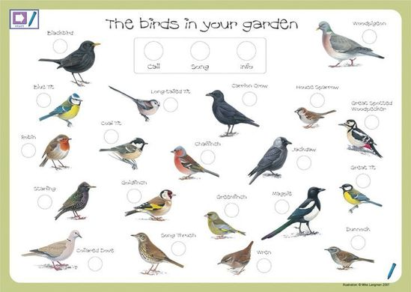
For a useful tick list of garden birds see the Nature Detectives worksheets from The Woodland Trust
Instructions for making Handmade Handkerchiefs from old clothing
Materials: Old top/piece of clothing/pillow case
Scissors
Iron
Ruler
Needle
Thread
Pins
Method:
- Choose an old top or piece of clothing, one for each girl (ideally cotton if using if against your face.)
- Iron the fabric before you start folding. This takes out any lumps or bumps and helps flatten it.
- Cut the fabric into a 9inches (22cm) by 9 inches (22cm) square. (you can make them smaller or bigger if needed, but this will give you an 8x8 in square typical size for a lady’s handkerchief.)
- Fold over the edges by 0.5inches/1cm and pin it to keep it in place. Make sure the wrong side (back) of the fabric is facing up when doing this and pinning the wrong side to the wrong side.
- Press the folded edges flat with an iron to crease it. This will also keep the material in place and make it easier to sew.
- Time to sew! For the younger ones it may be easier to have a thread that stands out against the colour of the material so they can see what they are sewing. Secure the folded fabric with a back stitch along the folded edge. (This stitch can be changed due to the age group you are sewing with.)
- Tie off the threads and you have a handkerchief.
Further work: try embroidering a corner of the handkerchief, you could try adding some initials or a flower in the corner.
Brownie Pack Audit Sheet and Action Plan
This sheet will help you to think about how your Pack can get better at the 3Rs – Reduce, Reuse, Recycle.
General
Do your leaders know the 3Rs (Reduce, Reuse, Recycle)? | Yes/No
Do your leaders know what happens to the rubbish from your meeting place? | Yes/No
Does your group consider their waste a problem? | Yes/No
Reduce
Do you use both sides of paper at Brownies/Guides? | Yes/No
Do you have a scrap paper drawer? | Yes/No
Do leaders print out paper copies of letters? | Yes/No
Reuse
When you have an event or go camping as a group do you use washable cutlery and plates? | Yes/No
Do you use napkins or kitchen roll at events or camping? | Yes/No
Does uniform (jumpers/shirts/neckers) get used again? | Yes/No
Recycle
Is there a recycling bin at the place where your group normally meets? | Yes/No
When you have food for events do your leaders calculate exactly how much you need to reduce food waste? | Yes/No
Does your group use recycled products like paper and plastic? | Yes/No
Look in the bin at the end of a Brownies or Guide session. Record the contents here:
One you have answered all the questions, it’s time to make your Action Plan.
ACTION PLAN
Think of some ways you can reduce, reuse or recycle more in your Brownie or Guide Group:
Reduce
E.g.
Reuse
Recycle
Look in the bin at the end of a Brownies or Guide session in the term after you have implemented these changes. Record the contents here:
Have you reduced the rubbish that your Brownie or Guide group creates?
Check again at the end of term. Keep an eye on it!
Table for recording plastic use
(Adapted from Lucy Siegle’s book – Turning the Tide on Plastic)

Item made of plastic | Where was it from? | Number of uses | Where did it end up? | Could you have avoided it? | If yes, how?
Examples:
Plastic bottle | School canteen | 1 | Recycling bin at home | Yes | Reusable bottle
Wrapping from a magazine | Subscription through the post | 1 | Bin – non-recyclable | No

Instructions for Papermaking
This activity is great for teaching young people about recycling. It is active, fun and you end up with lovely homemade paper that can be turned into a gift or used for further crafty activities. You can also watch a video for this activity on our website here: https://youtu.be/ZdVKvRfbD-k.
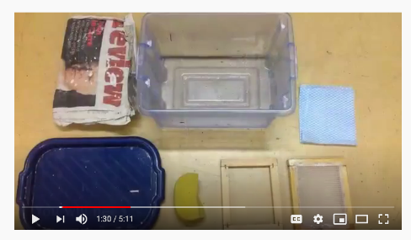
Materials:
Paper to be recycled – newspaper is ideal,
Warm water,
Bucket,
Stick Blender,
Mesh made from net curtain or muslin
Sponge,
2 J cloths or old towels,
Rolling pin Frame (to make this yourself you will need: wire mesh/wooden frame/screen/old picture frame/staple gun)

Time: 2 hours plus clearing up time.

Recommendation: This would be perfect to do over a weekend on camp as it can be left to dry.
Method:
- Tear scrap paper from your recycling box or old newspaper into small pieces, no larger than 2.5 cm and soak in a bucket of warm water. Do this for at least 30 minutes (overnight is ideal if you have the time.)
- Make a frame by stretching a screen/wire mesh over a wooden frame (an old picture frame is fine, or you could make your own out of old wood pieces.) Pull the screen as tight as you can and staple/nail it to the edges. Do the same thing with the screen across the bottom after turning over the edges so they aren’t sharp.
- Use a stick blender to mix the paper pulp. Keep blending until it is a soup-like consistency.
- Pour the soup like paper pulp into a tub filled with warm water.
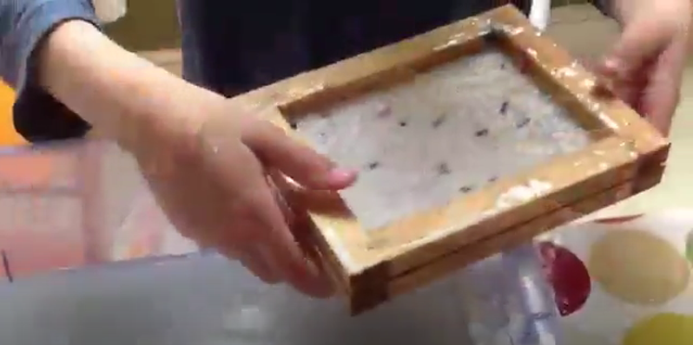
- Dip the frame into the tub and allow it to fill with the paper. Gently move it about under the water so it all gets covered.
- Lift the frame out of the tub, allow the water to drain and then with your hands press the fibres into the screen, forcing more of the water out.
- Place the frame, paper side down, onto a clean dry J cloth or towel. Lift the frame leaving the paper on the towel.
- Place another J-cloth or towel on top and press it together using a rolling pin.
- Peel the paper off the 2 cloths or towels and set aside to dry overnight.

Once dry, you can write on it, decorate it and cut it into new shapes!
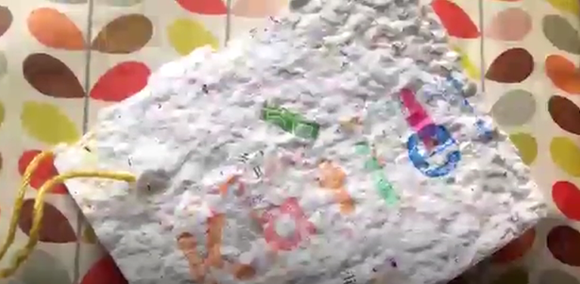

Further Work: You can make some lovely presents – perhaps for Christmas or Mother’s Day by pressing seeds, petals or biodegradable glitter into the paper. You will need to press them in as it is rolled out, but make sure it dries out properly, or they will start to sprout!

Template letter for Councillors and MPs
Your name
Guide/Brownie/Rainbow group
Guide group address

Date
Name of Councillor/MP
Address

Dear [Title and name of Councillor/MP]

I am a Guide/Brownie/Rainbow with [Name of your group]. We have recently been doing some work for our Recycle Devon badge and we have become aware of the problems we have worldwide with waste, especially plastic pollution in the oceans.

We have found out that 12.7 million tonnes of plastic is being put in our oceans worldwide every year, that’s a bin lorry load every minute. We have seen pictures of plastics trapping seals, whales and turtles and we have found out that seabirds are dying because there is plastic in their food. We want to stop this plastic from being in the seas in the first place. We want to protect our beautiful beaches and our marvelous marine life around world and along the Devon coastline.

We also know that plastic from litter in our streets gets into our rivers and then into the sea. We think we all have a part to play, which is why our group is doing/has done a litter pick/beach clean in our local area on the [enter date of litter pick or beach clean].

We would like to ask you to support work to reduce our unnecessary plastic waste, especially when we buy stuff from supermarkets. We would also like there to be tough action on plastic from large corporations, in line with the Plastic Pact, that has already been signed by over 40 large companies.

Thank you for supporting us in this very important issue. We want the world to be a better place when we grow up.

Yours hopefully,
[Sign your name here]
Index of badge links
Rainbows
Rainbows can earn parts of other badges by completing the challenges listed here.
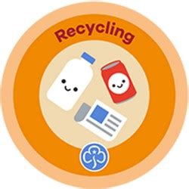 | Most parts of the Recycling Badge are covered while doing the activities for the Recycle Devon Girlguiding badge. Encourage rainbows to earn the whole badge by designing a Recycling superhero.
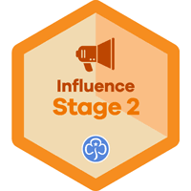 | Spreading the 3Rs message and making an impact will help Rainbows achieve their Influence Stage 2 Badge.
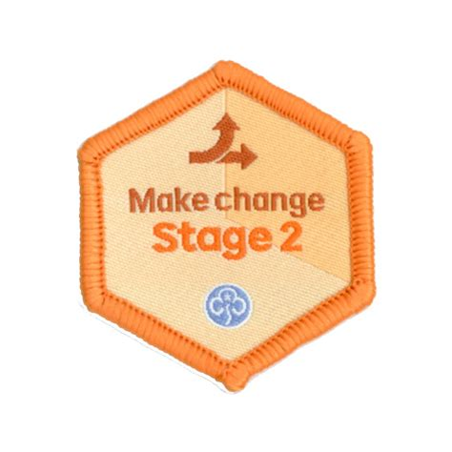 | Rainbows will work towards achieving their Make Change Stage 2 Badge by working through the activities for the Recycle Devon badge.
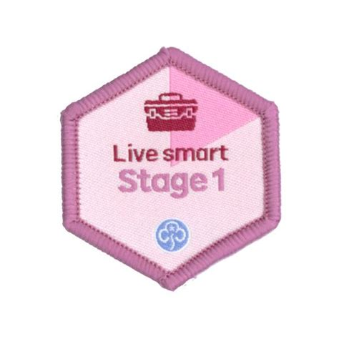 | Learning about fixing items will help Rainbows get their Live Smart Stage 1 Badge.
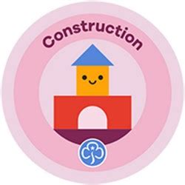 | Materials are an important part of recycling and learning about what can be recycled in your area can help Rainbows work towards their Construction Badge.

Brownies
Brownies can earn parts of the following badges by carrying out the activities and challenges on pages 4 and 5.
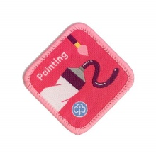 | The Painting Badge can be earnt by painting a poster about recycling – they could draw a poster in the style of their favourite painter!
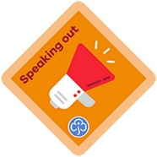 | Brownies can complete their Speaking out Badge by talking to a leader about the issues around waste and what to Reduce, Reuse and Recycle.
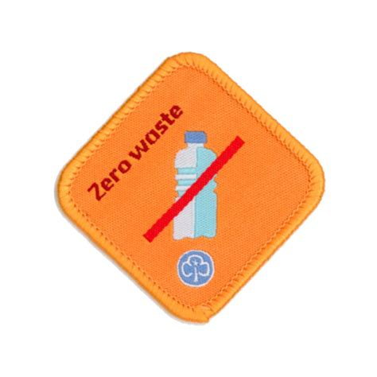 | Brownies can complete nearly all the Zero Waste Badge by completing the activities and challenges listed here. They will become waste aware by auditing what they throw away in a whole week, while working out an Action Plan to reduce waste will help them become a waste warrior.
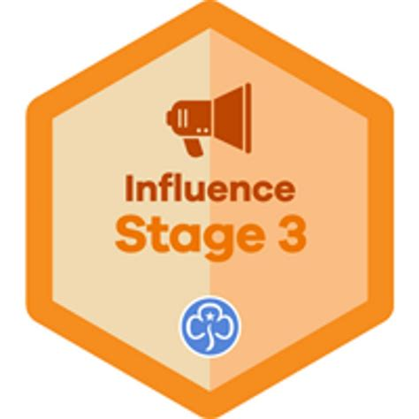 | The Influence Stage 3 Badge can be earned if brownies want to make positive changes around reducing waste and recycling more.
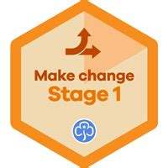 | Taking on the role of environmental detectives and helping clear litter in their local area can help achieve the Make Change Skills Badge.
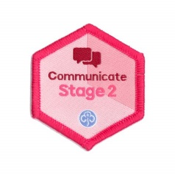 | By following the badge activities contained in this document Brownies can also work towards their Communicate Stage 2 Skills badge.
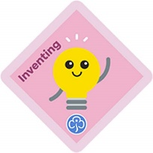 | Designing and thinking of a problem to solve around waste and the environment will help Brownies earn their Inventing Badge.

Guides
There are parts of some Guide Badges that can be earnt by completing sections of the Recycle Devon Guide Badge.
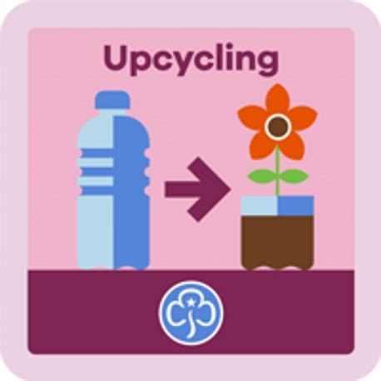 | Guides who complete an upcycling project and create something useful from recycled materials or junk can earn their Upcycling Badge.
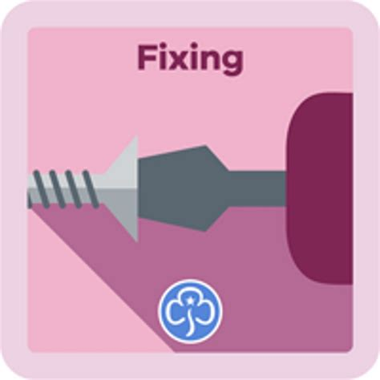 | Guides who learn to mend clothes, a bike and something at home can complete their Fixing Badge.
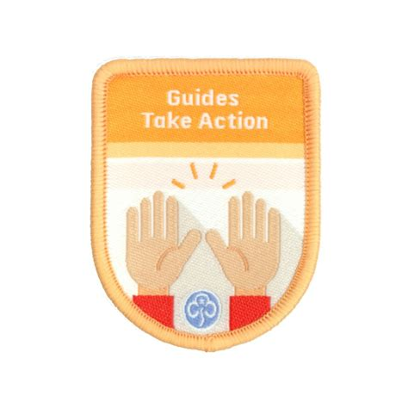 | The Recycle Devon badge can contribute a large part towards the Take Action Theme Award. To complete this Award Guides need to identify an issue and can campaign and influence and make change. Sustainability, litter and recycling will contain elements that count towards this Theme.
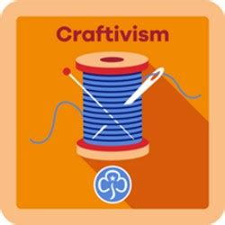 | Guides can complete part of their Craftivism Badge by designing and crafting something from recycled materials or with a sustainability and resource management message.
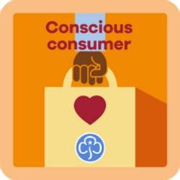 | Part of the Conscious Consumer Badge can be completed by thinking about and acting upon consumption of clothing, which is one of the most resource intensive industries in the world.
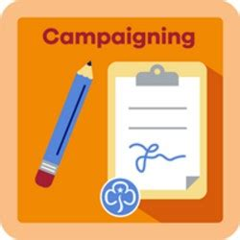 | Parts of this badge can be framed in a way to cover parts of the Campaigning Badge.

