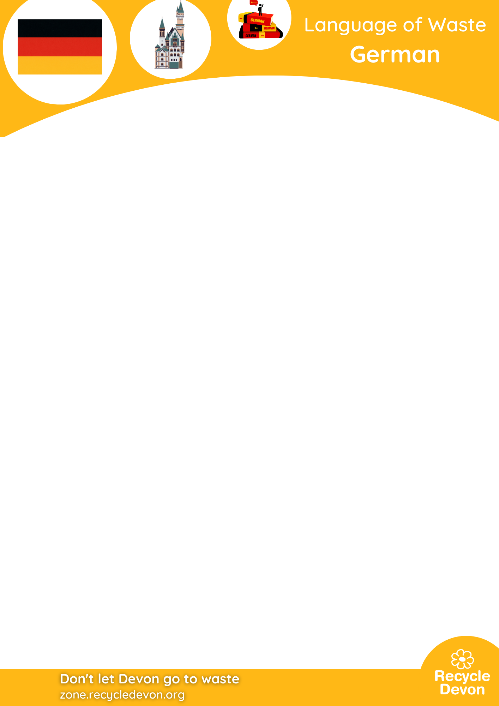
Match the German words to the English words

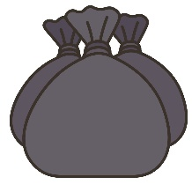  Waste | 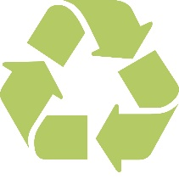  Recycling |   Bin
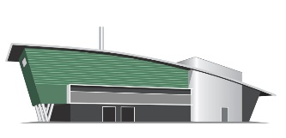  Energy from Waste | 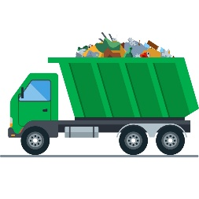  Bin lorry | 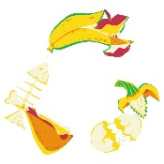  Food waste
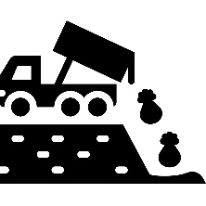  Landfill | 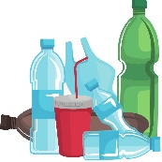  Plastic | 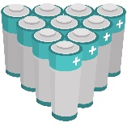  Batteries
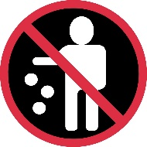  Litter |   Mending |   Sustainability

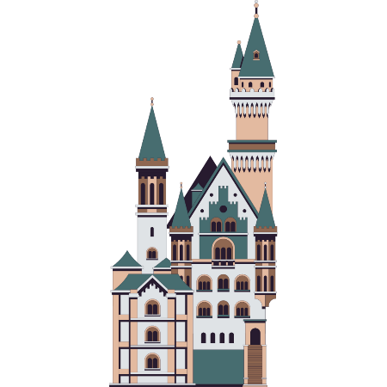
German is the second most spoken language in Europe, following Russian, with 100 million European speakers and 130 million speakers worldwide. English is the fourth most spoken language in Europe. Germany is known for being a clean country with excellent waste management policies and culture, setting an example for the world. It is also home to the castle that inspired Disney Land.

Translations
Abfall -Waste
Recycling
Mülleimer -Bin
Energie aus Abfall -Energy from waste
Müllauto -Bin lorry
Lebensmittelverschwendung -Food waste
Mülldeponie -Landfill
Kunststoff -Plastic
Batterien -Batteries
der Abfall -Litter
Reparatur - Mending
Nachhaltigkeit -Sustainability

